- COURT OF HONOR -
October 12, 2017
Boy Scout Troop 87

www.Scouting.GrovelandUCC.org

Presentation of Colors Name

Invocation Name

Welcome Name
Candle Lighting Opening Ceremony Name

Rank Advancements: Name Scout Master

Tenderfoot Name
Name
Name

First Class Name

Eagle Name

Skits

Merit Badges (See Back) Name, SM

Troop Activity Patch Presentation Name, SM

Commissioner’s Report: Name,

Announcements: Name,

Scoutmaster’s Closing Remarks: Name, SM
Closing Ceremony: Name

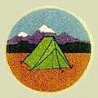
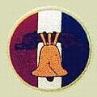
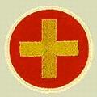
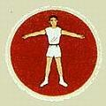
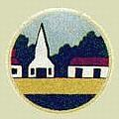

Merit Badges, Awards & Activities

Name Archery, Wilderness Survival
Name Fingerprinting, Fishing, Music, Pets, Swimming
Name Fingerprinting, Fishing, Personal Fitness, Pets, Swimming
Name Fingerprinting, Mammal Study
Name Emergency Preparedness, Radio, Welding
Name Rowing, Small boat sailing
Name Citizenship in the Community, Citizenship in the Nation, Fingerprinting, Pets, Swimming
Name Emergency Preparedness, Small boat sailing
Name Orienteering, Rifle shooting, Search and Rescue
Name Leatherwork, Shotgun Shooting, Wilderness Survival
Name Rifle Shooting, Welding, Woodcarving
Name Rifle Shooting, Welding, Woodcarving
Name Kayaking
Name Fingerprinting, Leatherwork
Name Chess, Geocaching, Swimming

* Bold type indicates an Eagle Required Merit Badge

